Reponse in burp suite gives a lot of information about the server.

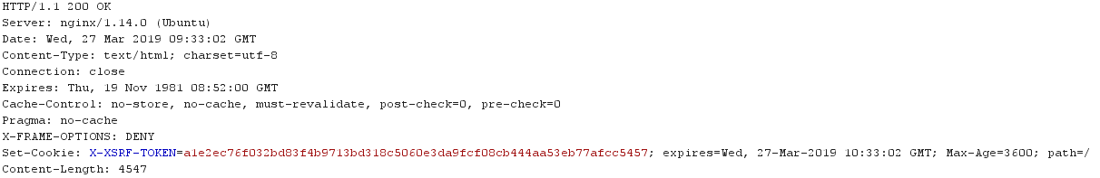

/composer.lock gives the dependencies used in the project.

